STRINGS
IN
JAVA

Program 1:
class StrTest1
{
public static void main(String[] args)
{
String s1 = "abcd";
String s2 = "xyz";
String s3 = "abcd";
String s4 = "xyz";

System.out.println("String - 1 : " + s1);
System.out.println("Hash Code of String - 1: " + s1.hashCode() );

System.out.println("String - 2 : " + s2);
System.out.println("Hash Code of String - 2: " + s2.hashCode() );

System.out.println("String - 3 : " + s3);
System.out.println("Hash Code of String - 3: " + s3.hashCode() );

System.out.println("String - 4 : " + s4);
System.out.println("Hash Code of String - 4: " + s4.hashCode() );
}
}

Output:-
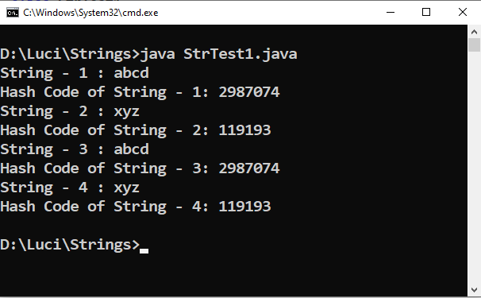

Program 2:
class StrTest2
{
public static void main(String[] args)
{
String s = "abcd";
System.out.println("String : " + s);
System.out.println("Hash Code of String - 1: " + s.hashCode() );
}
}
Output:-
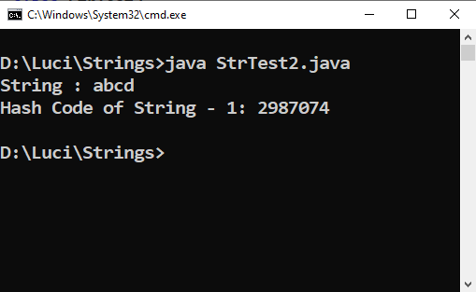

Program 3:
class StrTest3
{
public static void main(String[] args)
{
String s = "abcd"; //String Object is Immutable (Non - Changeable)
System.out.println("String : " + s);
System.out.println("Hash Code of String : " + s.hashCode() );

s = s + "xyz";
System.out.println("After Concatentation .......");
System.out.println("Hash Code of String : " + s.hashCode() );
System.out.println("String : " + s);

String s1 = "abcd";
System.out.println("Hash Code of String : " + s1.hashCode() );
System.out.println("String : " + s1);
}
}
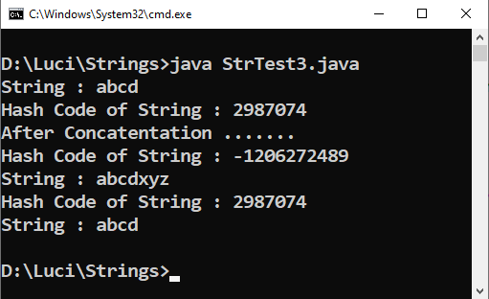
Output:-

Program 4:
class StrTest4
{
public static void main(String[] args)
{
String s1 = "abcd";

String s2 = new String("abcd");

char[ ] A = { 'a' , 'b' , 'c' ,'d' , 'e' , 'f' };
String s3 = new String(A,0,4); //Character array to String Conversion ........

System.out.println("String - 1 : " + s1);
System.out.println("String - 2 : " + s2);
System.out.println("String - 3 : " + s3);

System.out.println("Hash Code of String - 1: " + s1.hashCode() );
System.out.println("Hash Code of String - 2: " + s2.hashCode() );
System.out.println("Hash Code of String - 3: " + s3.hashCode() );
}
}

Output:-
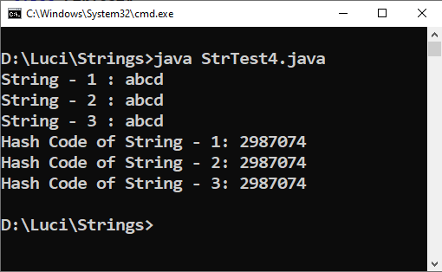

Program 5:
class StrTest5
{
public static void main(String[] args)
{
String s1 = "Hello"; //Immutable Object

StringBuffer s2 = new StringBuffer("Hello");
String s3 = "abcd";
String s4 = "xyz";

System.out.println("String - 1 : " + s1);
System.out.println("Hash Code of String - 1: " + s1.hashCode() );

System.out.println("String - 2 : " + s2);
System.out.println("Hash Code of String - 2: " + s2.hashCode() );

s1 = s1 + "xyz";
s2 = s2.append("xyz"); //append concat ,+ not works

System.out.println("String - 1 : " + s1);
System.out.println("Hash Code of String - 1: " + s1.hashCode() );

System.out.println("String - 2 : " + s2);
System.out.println("Hash Code of String - 2: " + s2.hashCode() );
}
}
Output:-
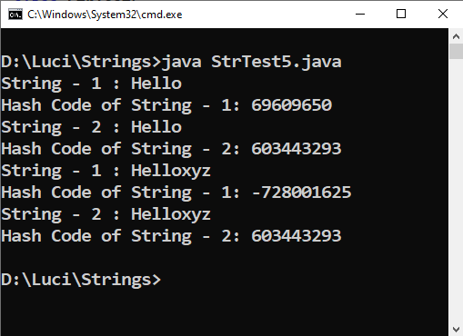

Program 6:
import java.util.*;
class TestStr1
{
public static void main(String[] args)
{
Scanner sc = new Scanner(System.in);

String [ ]s = new String[5];
int i;
for (i = 0 ; i < 5 ; i++ )
{
System.out.print("Enter the string:");
s[i] = sc.next();
}
System.out.println("The given string are:");
for ( i = 0 ; i < 5 ; i++ )
{
System.out.println(s[i]);
}
}
}

Output:-
